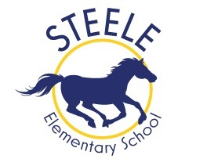 STEELE ELEMENTARY MARKETING OPPORTUNITIES 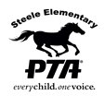
2018/19Year-Round Benefits Jan 1, 2019 - Dec 31st, 2019
 | Partner Page Web link  Deadline to receive full year-round benefit:  November 1, 2018 | Banner Sponsor  Deadline:November 1, 2018 | School Directory Ad  Deadline: November 1, 2018
Benefits | Web link  Steele Elementary website partner page with link, logo and tagline  4 Steele partner communications/year | 3x6 Banner  Template border design will include your business/company logo or image (4 color) and tag line. Printing and placement on school fence included  (location to be determined by PTA) | 2018/19 Steele School Printed & Online Directory  Opt in “phone book”  Distribution: ~450 Steele families/Staff
Annual Investment | $250.00 | $750  or  $900  (Includes ½ page Directory Ad)  $100 savings  $600 (sponsorship renewal –  Banner from previous year) | Ad Size School Directory  (5 1/2" x 8 1/2")  1/3 page $250  1/2 page $325  2/3 page $400  Full page $500

Sponsorship benefits/prices are subject to change

Steele Stallion Fund
In 2017, Steele will continue the annual giving campaign. Donations will support specific initiatives to maintain and improve excellence in education. If you would like to support this community effort to benefit neighborhood K-5 students, visit www.coloradogives.org/SteeleStallionFund for more information.
Contact Maureen Savage at steelevp2@gmail.com with any sponsorship/ad questions

